Io and Europa Atmosphere Detection through Jovian Mutual Events
Scott Degenhardt
International Occultation Timing Association (IOTA)
2112 Maple Leaf Trail, Columbia, TN, USA
scotty@scottysmightymini.com

S. Aguirre, M. Hoskinson, A. Scheck, B. Timerson
IOTA

D. Clark
Administaff/Humble ISD Observatory

T. Redding
IOTA, Redding Observatory South

J. Talbot
RASNZ Occultation Section
Abstract
Approximately every 6 years the orbital plane of the Jovian moons turns edge on from earth’s line of sight giving us the opportunity to time the eclipses and occultations arising from this geometry known as Jupiter Mutual Events (JME). These timings help to refine the residuals in the orbital elements of Jovian moons.

While taking several tens of minutes of wing data surrounding an occultation by Io in 2009 during that JME cycle, an anomaly was detected in the lightcurve prior to and following the actual occultation. Analysis of this anomaly led to the hypothesis that it was the result of atmospheric extinction of the light from the occulted moon by the atmosphere of Io. The same anomaly was then found when Europa was the occulting body. Occultations by Ganymede showed no dimming anomaly.

Eleven observers from 4 countries contributed 53 data sets for 28 individual events in an observing program for the study of this phenomenon. This paper will detail the results including camera response, observing method, reduction method, and atmospheric extinction detection. The atmospheric extinction hypothesis is supported by several independent methods which will also be detailed. Derived atmospheric models will be presented including a noted asymmetry.

- Introduction
On August 7, 2009 during the 2009 JME cycle S. Degenhardt recorded the shadow from Io eclipsing Europa and then 23 minutes later the body of Io occulting Europa. Data was recorded for 46 minutes continually centered on this double JME in an attempt to create one continuous lightcurve (LC) connecting the eclipse, occultation, and 5 minutes of wing data on each end. Figure 1 is the resulting LC for the events. An anomalous dimming was found in the LC starting about 14 minutes prior to the occultation, and after the occultation an anomalous brightening occurred. The source of this anomaly was investigated and several experiments were set up to try to determine its origins.
Camera response, recording method, reduction method, and possible extinction of the occulted moon’s light by the atmosphere of the occulting moon were all explored in detail. Predictions based on an atmospheric extinction model were created by using the start of the anomaly and the asymmetry present in the LC of 20090807. These extinction predictions were applied to the next Io occultation of Europa on 20090901. Degenhardt recorded this follow-up event in its entirety, and the dimming based on the atmospheric extinction model occurred as predicted (Figure 2a).
A set of predictions for the remaining Io occultations to the end of that current JME cycle were created and a global call for observers was made in an effort to validate or refute the atmospheric extinction model. The request entailed recording several tens of minutes of data before and after the scheduled occultation. It is in this data outside the occultation event (wing data) where the presumed extinction events are detected. Eleven observers from 4 countries contributed 53 data sets for 28 individual events using a wide variety of video cameras, telescopes, recording methods, and reduction techniques in this observing program called the Io Atmospheric Extinction Project (IAEP) (Degenhardt, 2009) for the study of this phenomenon.

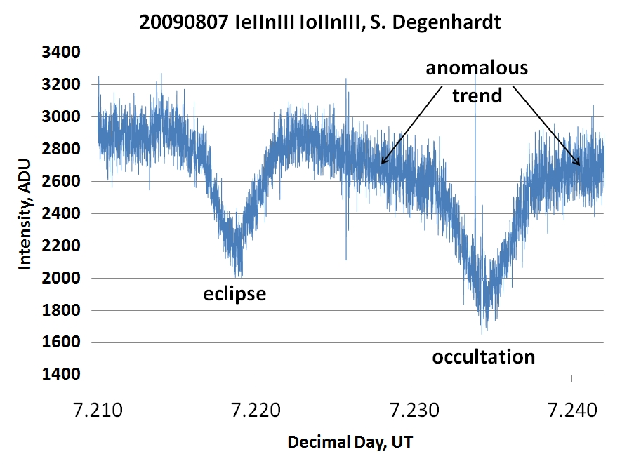
Figure 1. Double JME of 20090807 with anomalous dimming.

- LC Results
Figure 2 summarizes the typical results of occultations by Io, Europa, and Ganymede when several tens of minutes of wing data are taken. In each plot the predicted occultation times are highlighted by vertical dashed lines. For both Io and Europa a noted dimming trend began many minutes before the actual occultation. After the occultation a brightening trend began until nominal intensity was eventually regained.

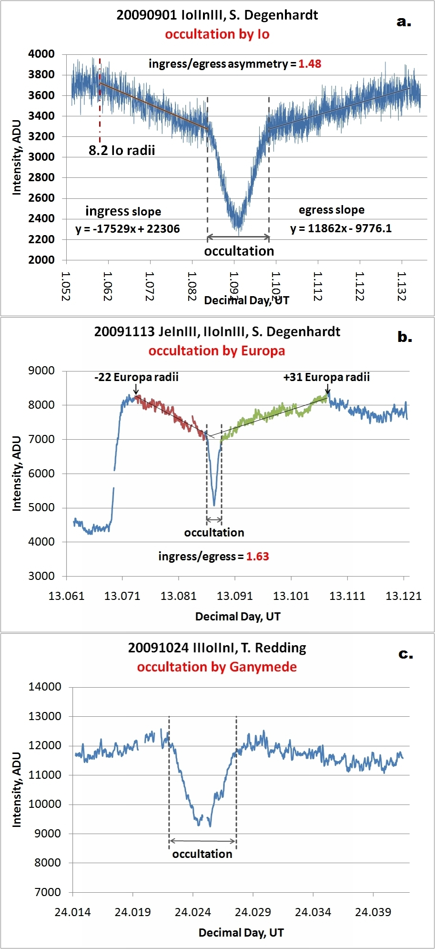
Figure 2. Typical derived LCs submitted to this study.

When Ganymede was the occulting body no such dimming was detected in the available data of our study. A brightening trend, or raised shoulders, occurred when Ganymede was the occulter (Figure 2c).

- Discussion
3.1 Simulated LC of merging intensities
In order to assess the LCs of this study it is important to understand what the expected response should be for two merging moons or light sources. A simulation of an occultation was performed in a lab setting by creating two artificial moons, one fixed and the other mobile. One point source was created by taking a silver plated tip of a pin mounted to a sheet of black card stock. A second tip of a pin was mounted to a wooden dowel attached to a rail that could be slowly moved by turning a threaded rod. A single white LED powered by a DC source illuminated the two pins and the rail was moved slowly to create an occultation of the pin fixed to the black card stock. “Humps” in the wings were found in the resulting LC of the simulation representing a nonlinear increase in detected light occurring pre and post occultation. We have named this trend “raised shoulders”, and is what we see when Ganymede occults another Jovian moon. The simulation LC superimposed on the actual measurement of two merging intensities of an occultation by Ganymede is shown in Figure 3. These raised shoulders confirm that the dipped or lowered shoulders of the Io and Europa occultations are indicating a loss of intensity somewhere within the measurement aperture of the photometry reduction software surrounding the event moons.

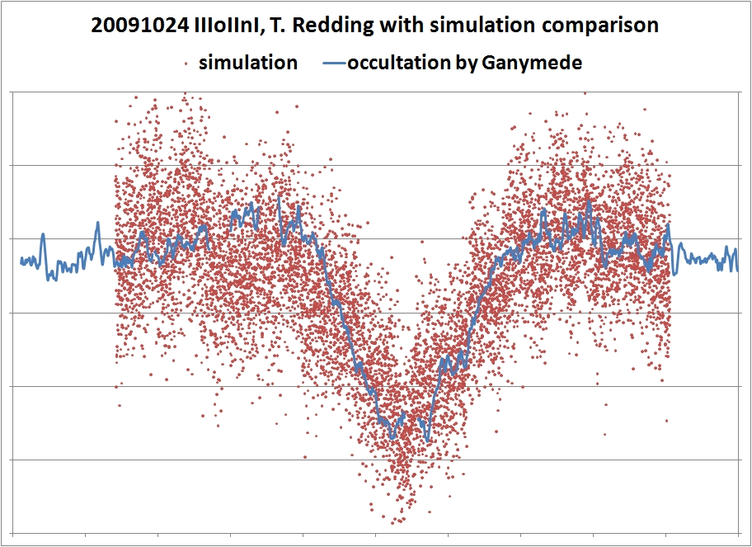
Fig 3: Simulation (red dots) data is compared to a Ganymede occultation (blue line).

3.2 Source of dimming trend
The LC reductions of Figure 2 are created by placing one large measurement aperture around both the occulting and occulted moons. Since the moon’s Airy disks are merging, the light from one moon that spills into the disk of the other moon is common for each. This gives one the opportunity to normalize the light of one of the merging moons to the other. If we then measure the individual intensities of each moon, we soon discover that the moon that is being occulted by Io or Europa is the source of the dimming intensity trend. This is demonstrated as seen in Figures 4, 5b, and 5c by normalizing the light of the occulted moon by the light of the occulter.
For the 20090923 Io occultation of Europa shown in Figure 4, Redding imaged the JME with a 9 meter effective focal length providing a very wide separation of Io and Europa in order to do individual photometry on each moon. The results of this observation demonstrates that, when the limb of Europa was about 5 Io radii distance from the center of Io, Europa began dimming and continued dimming as it approached Io.

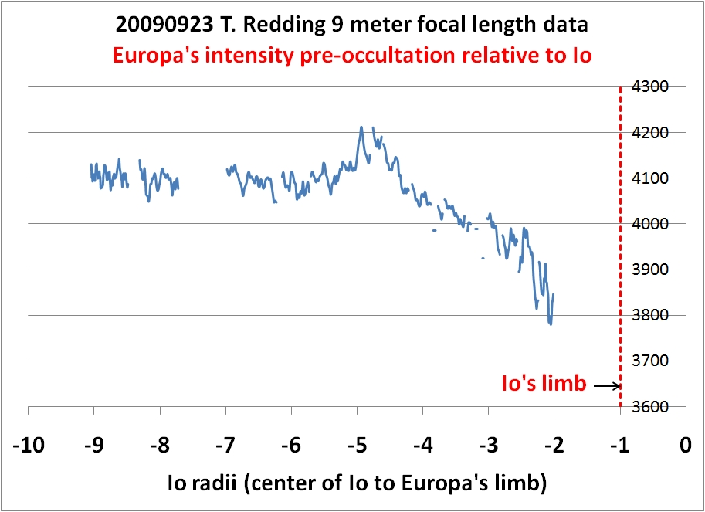
Figure 4. LC photometry of Europa relative to Io prior to Europa being occulted by Io.

In Figure 5 we see three independent methods demonstrating the source of the dimming trend. Figure 5a shows a 3D intensity profile of a raw video frame of the Io occultation of Europa on 20091101 at two different moments in time. Europa becomes shorter relative to Io as Europa gets closer to Io, i.e. Europa loses intensity relative to Io.
Figure 5b shows two different photometric methods compared to each other yielding identical results. Degenhardt’s Io plus Europa combined intensity LC (when intensity measurements for both moons were taken inside one large measurement aperture) shows a dimming trend that correlates exactly to a loss of light by Europa in the individual LC photometry of Redding’s data (when each moon is measured individually and the occulted moon’s intensity is normalized by the intensity of the occulting moon).
Figure 5c demonstrates that a loss of light is not found when Ganymede is the occulter. The curves in Figure 5c show that the light of Europa (red dots) does not dim as it is occulted by Ganymede, but when Europa is occulted by Io (blue line), Europa experiences an extinction trend.
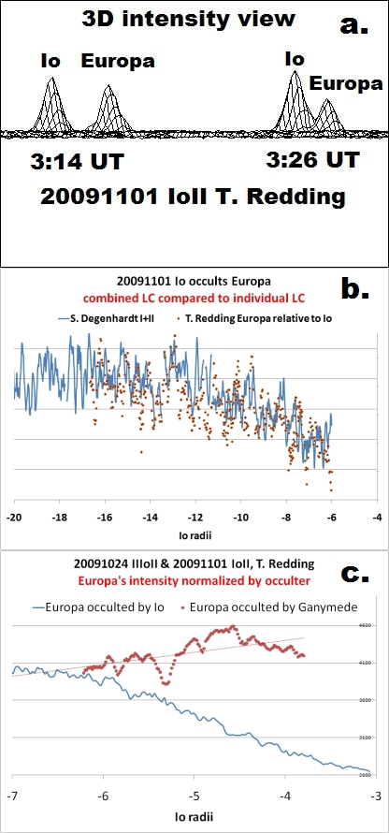
Figure 5. (a) 3D view of the intensity profiles of the 20091101. (b) Independent photometry methods yield the same result. (c) Ganymede does not present the same extinction trends.

3.3 Photon doubling effect (PDE)
We have linked the dimming trend in the combined LC to the moon that is passing behind Io or Europa. Investigation of the raised wing data in both a Ganymede occultation and a simulation of two merging moons revealed a nonlinear increase in brightness in their wing data (Figure 3). We refer to this nonlinear brightening phenomenon as a photon doubling effect (PDE).
When a point source is focused on a CCD camera, an Airy disk is formed where a somewhat Gaussian distribution of intensity exists. The center of the focused spot or Airy disk has the peak intensity, and the farther from the center of the disk, the lower the intensity. At some point, the intensity drops below the threshold of the CCD’s ability to detect the photon flux rate. As two Airy disks begin to merge, outer rings where photons are striking the detector just below detection start to overlap (Figure 6). In the region between the two merging spots, an overlapping of photons increases the photon rate above the detectable limiting threshold, thus producing a signal for these previously undetected photons (Figure 7).
The larger a telescope’s central obstruction, the more photons that are pulled from the central part of the Airy disk and redistributed in the outer rings. Therefore PDE is likely to be more or less dominant in an LC depending on the optical characteristics of the observing system.

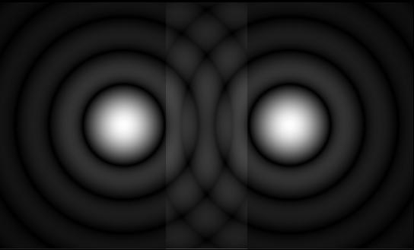
Figure 6. Two merging Airy disks
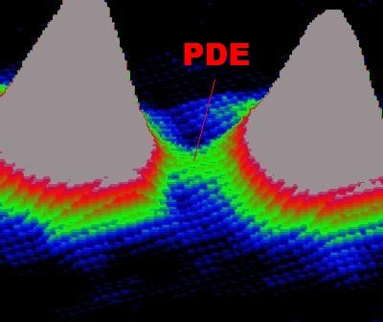
Figure 7. False color enhancement of a video frame showing a “light bridge”, the potential source of PDE.

3.4 Atmospheric modeling
The dimming trend in the combined intensity LCs potentially offers insight into structural information of the tenuous material surrounding Io and Europa. The start of ingress and end of egress of dimming could mark the outer boundaries of the atmospheres. The amount of extinction magnitude loss could one day quantify the amount of material involved in the extinction. An asymmetry was also noted in the slope of ingress of extinction compared to egress in all Io and Europa LCs.

3.4.1 Io atmospheric model
For Io, the noted asymmetry has been tentatively linked to Io’s limb orientation relative to Jupiter during the occultation. If the ingress motion of the moon being occulted by Io was on Io’s western limb when Io was west of Jupiter, then the ingress/egress slope asymmetry ratio was always greater than 1 Figure 8a). If Io was east of Jupiter and the ingress motion of the moon being occulted was on Io’s western limb, then the ingress/egress slope asymmetry ration was always less than 1 (Figure 8b and 8c). The geometry of this asymmetry represents a longer duration of extinction on the Jupiter facing limb of Io. This may possibly indicate that some of the material leaving Io is streaming back towards Jupiter either by gravitational pull or magnetic flux line attraction.
Slope ratios for Io have been documented from 0.28:1 to 0.86 when Io was east of Jupiter while occulting with its western limb, while ratios of 1.48 to 1.62:1 have so far been derived when Io was west of Jupiter while occulting with its western limb. The typical intensity loss from atmospheric extinction was around 0.12 magnitude.
In events not recorded long enough for the LC to return to the nominal level, extrapolation of the beginning of ingress or the end of egress for estimations of the extent of the atmospheric extinction can be accomplished using the slope ratio. Using the slope ratio of 1.48 in the occultation of Figure 8a, extrapolation to the end of egress gives an estimated extinction zone out to 12.1 Io radii.
Side-on occultations where Io is predominantly moving towards or away from earth present very complex LCs such as found in Figure 8b. It is known that Io orbits Jupiter in a structure of material called the Torus of Io (Schneider et al. 1991). Figure 9 is an image of the Io Torus taken by Catalina Observatory (Schneider, 1991). In Figure 8b, two “notches” could potentially represent extinction by the thicker material of the Torus due to the proximity of Io and Europa at the eastern edge of its Jovian orbit. Side-on occultations experience around twice the extinction magnitude loss compared to occultations away from the Torus tips, possibly due to the increased amount of material in our line of sight at the eastern and western tip of the Torus.

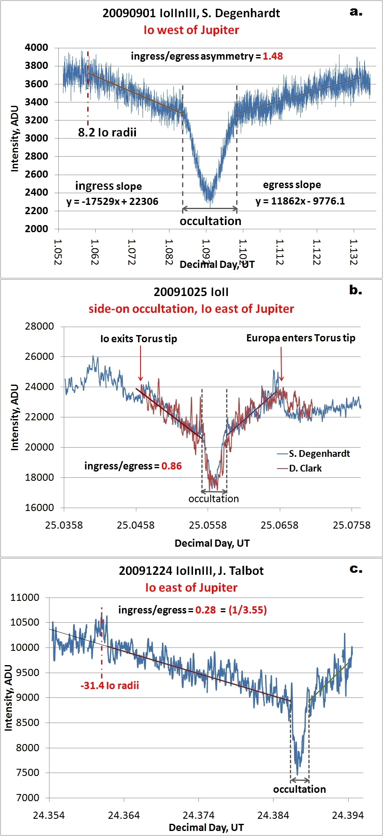Figure 8. Various asymmetries of the Io LC.

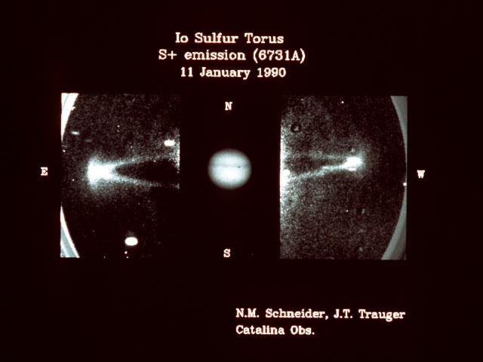
Figure 9. Io’s sulfur torus (Schneider et al. 1990)

3.4.2 Europa atmospheric model
The modeled size of the Europa atmosphere was noticeably larger than the Io atmosphere. Figure 2b highlights this, with ingress starting at about 22 Europa radii and ending at about 31 Europa radii. An asymmetry of 1.63:1 was derived. The amount of magnitude loss due to extinction preliminarily seems to be about 0.2 magnitude, twice that of Io’s. However, nominal intensity was never documented on ingress due to Io emerging from Jupiter’s shadow, or on egress due to insufficient wing data. So the slope ratio and magnitude loss estimates have some unknown certainty for this particular LC. There was a limited number of Europa LCs in this study, so much more data needs to be collected to refine these same parameters for Europa.

3.4.3 Ganymede atmospheric model
There is currently no modeling information yet gleaned from our LCs for Ganymede, as no dimming was noted in any of them. The most notable anomaly in the Ganymede LC is the PDE.

3.4.4 Jovian transits of Io.
Donald Parker contributed two photographs of Io transiting Jupiter to this study. Through an advanced processing technique, the intensity surrounding Io and Io’s shadow showed an extinction trend as you near the limb of Io (Figure 10). The same extinction trend was measured in the intensity surrounding Io’s shadow projected on Jupiter.

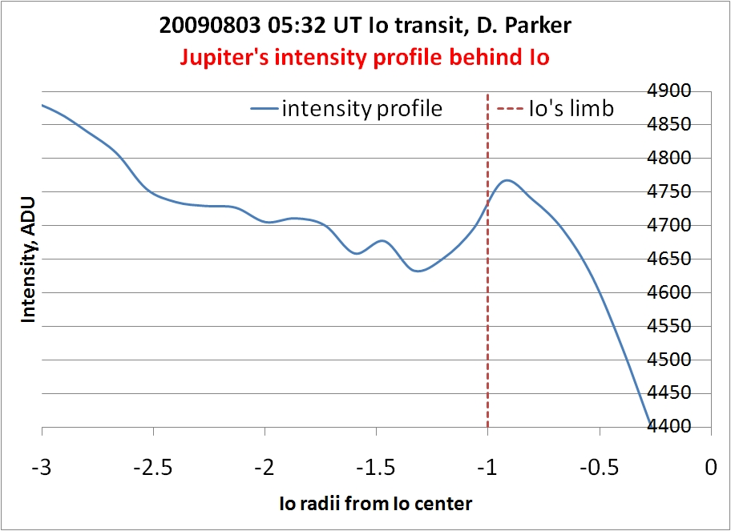
Figure 10. Intensity trend of the Jovian surface behind Io.

Probably the most interesting Io transit result was found by taking a processed background image of Jupiter and subtracting it from an Io transit photo. Figure 11a shows Io’s shadow as the white disk in the middle of the photo. A concentric disturbance is visible beyond the white disc out to almost 2 Io radii. Figure 11b has a circle drawn highlighting the outer boundary of the disturbance likely caused by extinction from Io’s atmosphere.
The disturbance of objects behind Io has been found in several other Io transit photos. One in particular was taken by Voyager on 19790213 (NASA et al., 1979) where Io is partly in front of the Great Red Spot. Io’s atmosphere seems to cause the Red Spot to be paler or less red. This may be one clue that the red end of the spectrum is being most absorbed by the material that makes up Io’s atmosphere. Our video cameras are generally more sensitive to red light, so extinction of red light would be more detectable than blue light.

3.4.5 Jovian Extinction Events (JEE)
On 20100106 T. Redding observed part of an event where Ganymede passed behind Europa’s atmosphere from our line of sight. This was a conjunction of Europa and Ganymede with no actual occultation taking place. Weather prevented imaging of the entire conjunction from beginning to end, but of the minutes that Redding recorded, the combined LC showed that out to 16 Europa radii Ganymede was suffering increasing extinction as it approached Europa.
The hypothesis that the notches in Figure 8b represent extinction by the Torus material at the tips of the Torus potentially means that whenever any object passes behind these tips, extinction may be experienced. JEEs can be observed independent of the JME cycle. Predictions for JEEs for 2010 can be found in the References (Degenhardt, 2010).
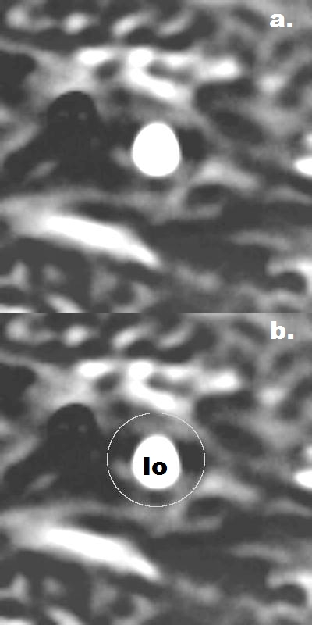
Figure 11. Io shadow transit image provided by Donald Parker and processed by Scott Degenhardt. Outer edge of disturbance is circled in 11b.

- Previous studies
4.1 Previously proposed atmospheric models
Burger et al. (2001) showed that Io’s atmosphere is detectable at least out to 6 Io radii. They also noted detecting a possible asymmetry of the shape of Io’s atmosphere of about 1.7:1. These numbers fall within the various sizes and asymmetries we have documented with our limited database of LCs.
Brown et al. (1996) estimated the Europa atmosphere being at least 25 Europa radii and Burger et al. (2004) discusses detecting a trailing cloud longer than the leading cloud around Europa.

4.2 Natural Satellites Data Center archives
The Natural Satellites Data Center (NSDC) of IMCCE maintains the database of archived JME LCs (NSDC, 2010). A modeling of one of the occultations by Io in the 2003 LC database yielded the following from Monterrey (Arlot et al., 2003) in Figure 12. Note the similar ingress/egress asymmetry of our LCs of 1.62:1 when Io was west of Jupiter while occulting with its western limb.

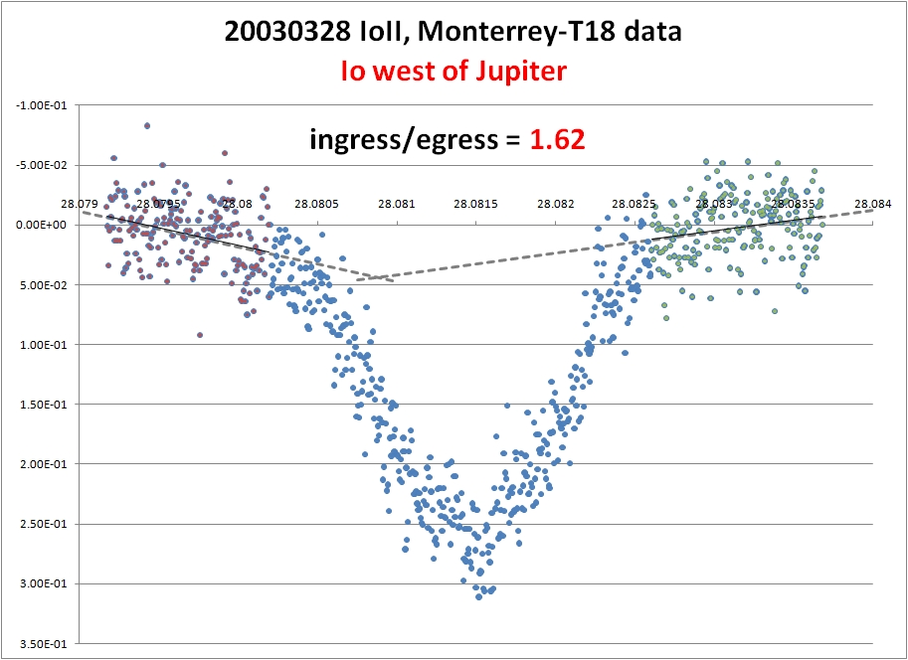
Figure 12. March 28, 2003 Io occultation of Europa retrieved from the IMCCE data base (Arlot et al., 2009).

Searching the LCs in the NSDC database shows that none have the extended wing data necessary for us to do a comparative study to our extended wing data trends. In most cases we collected a minimum of 30 minutes of data on either side of the predicted center time of the JME. The LC in Figure 13b was two full hours of video and it still failed to capture the end of egress and include some reasonable amount of nominal flat baseline intensity for statistics. Figure 13 highlights the need for several tens of minutes of wing data in order to capture the extinction events in their entirety. Figure 13a shows just six minutes of wing data, while Figure 13b is the same event displaying the entire two hour LC.
A reference for the standard observing and reduction method for JMEs has been published for IOTA by B. Timerson, (Timerson, 2009) and the web address for that can be found in the References. The standard procedure established by IOTA is to acquire only one or two minutes outside the predicted start and end time of an event for wing data. Our research shows that this is not enough to capture the entire extinction LC. Short wing data is a likely reason past JME observations have missed this method of extinction detection.

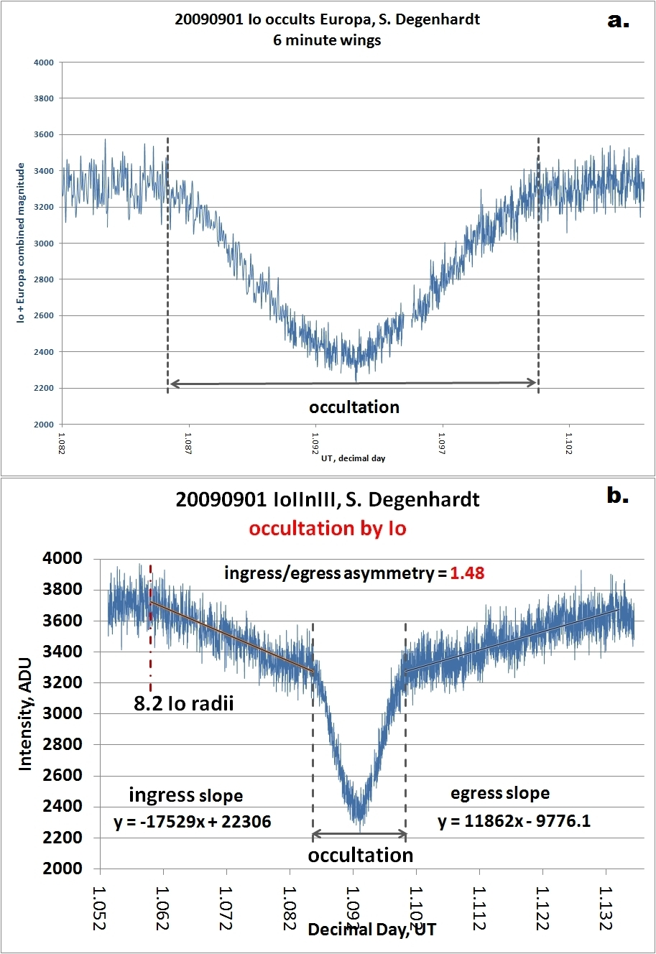
Figure 13. Comparison of same event, one LC with six minute wings (common in the IMCCE archives) and the same event with 1 hour wings.

- Dominant PDE in combined LC
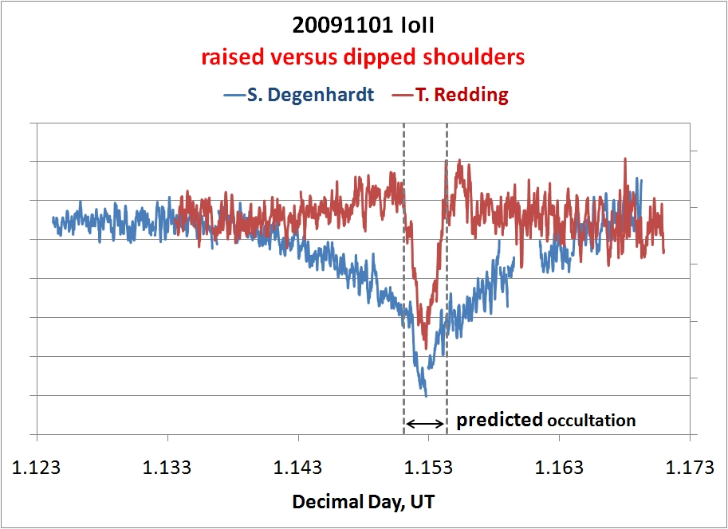
Figure 14. Two different combined LCs for the same observed event.

Figure 14 demonstrates two different combined photometry LCs for the same observed event. Degenhardt and Redding independently observed the 20091101 Io occultation of Europa. Degenhardt’s combined LC showed the dimming trend in the wing data. Redding’s showed raised wing data.
In combined LC photometry a large target aperture is measuring all intensities within the measurement area. There are a number of intensity sources in the measurement area that contribute to the final resulting LC. The target measurement aperture is the sum of the following intensities:

moon1 + PDE between moon1 and moon2 + moon2 + sky glow + Jovian glare + inherent noise

Correct use of background apertures should cancel out some of the unwanted intensities. What should be left in the final LC measurement is:

moon1 + PDE between moon1 and moon2 + moon2

If during merging the rate of PDE growth exceeds the loss of intensity in one moon, then the final combined photometry LC will show raised wings like Redding’s. Further investigation of Redding’s video revealed that even though his combined LC showed raised wings, both the 3D intensity plot and individual photometry of Europa document the extinction of the occulted moon’s light (Figure 5). It is therefore possible to have captured the extinction and not see dipped wings in the final combined LC. About 10% of the LCs in our study did not have dipped wings for Io and Europa occultations but did capture the extinction, as was determined through the alternate methods of detection such as the 3D intensity profile and individual photometry. More studies need to be done to characterize PDE effects on JME LCs.

- Conclusion
An anomalous dimming trend in the extended wing data of JMEs was discovered. The source of the dimming was found to likely be due to atmospheric extinction of the light of any moon being occulted by Io or Europa. Occultations of moons by Ganymede displayed no such dimming at the same scaled distances compared to Io and Europa. Numerous independent methods show this dimming is real and not an artifact of camera response or processing. These results were obtained by a diverse set of observers, video cameras, recording methods, reduction techniques, and analyses.
Asymmetry has been noted in the slope of the ingress of extinction compared to egress that has been linked to the geometry of the occultation. Slope ratios for Io have been documented from 0.28:1 to 0.86:1 when Io was east of Jupiter and occulting with its western limb, while ratios of 1.48:1 to 1.62:1 have so far been derived when Io was west of Jupiter while occulting with its western limb. This asymmetry may possibly indicate that some of the material leaving Io is streaming back towards Jupiter either by gravitational pull or magnetic flux line attraction. The typical intensity loss from extinction was around 0.12 magnitude for occultations away from the eastern or western tip of Io’s Torus, while side-on occultations at the tip of the Torus experience around twice that extinction.
An ingress/egress asymmetry of about 1.6:1 was noted in one Europa LC. An insufficient number of Europa LCs were acquired to connect the asymmetry to a specific occultation geometry. Intensity loss due to extinction by Europa’s atmosphere has not been fully determined due to insufficient statistics, but preliminary estimates are around a loss of 0.2 magnitude.
The beginning and end of the extinction phenomenon places some boundaries on the material causing the extinction. For Io, occultation by the limb facing away from Jupiter begins to cause extinction between about 5 to 9 Io radii (as measured from the center of Io to the limb of the moon being occulted). The extinction effect at the Jupiter facing limb extends for 10 to 30 Io radii. This fits with the findings of Burger et al. (2001) that showed Io’s atmosphere was detectable out to 6 Io radii. They also noted a possible asymmetry of the shape of Io’s atmosphere of about 1.7:1.
The Torus of Io can potentially be measured through JEEs. Notches in the LC of side-on Io occultations have been linked to the tip of the Torus of Io where the line of sight material is thickest. It is estimated that Io itself should undergo a dimming of 0.1 to 0.2 magnitude every time it passes through the eastern and western tips of the Torus due to this alignment of Torus material. During 2010 Io and Europa will pass behind the Io Torus tips several times a week presenting more JEE measurement opportunities.
There is only one nearly complete Europa LC in our database, and it shows that the ingress extinction started as far out as 22 Europa radii (as measured from the center of Europa to the limb of the moon being occulted) and the egress extinction ended as far out as 31 Europa radii. Far more data needs to be collected for Europa to derive better statistics, but this falls within the bounds of the Brown et al. (1996) estimates of Europa’s atmosphere being at least 25 Europa radii.
Data mining of the IMCCE NSDC LC database may provide more study data. The short wing data typically found with these will limit the amount of derived information.
Techniques could be developed to invert these types of extinction lightcurves to create a 3D model of the Io and Europa atmosphere.
Atmospheric imaging through transit photography could be improved if one were to image a transit of Io or Europa, and then image Jupiter exactly 1 rotation before or after the transit to obtain an optimal background image for processing.
One final lightcurve highlights the ease with which these extinction events can be recorded. The Figure 15 LC is a recording T. Redding made of the 20090923 Io occultation of Europa through his 80mm Vixen finder scope. The extinction trends were captured with this meager setup.
Every amateur and professional astronomer should begin planning for the next JME cycle which starts again in 2014. They presently could also be observing Jovian Extinction Events. JEEs are observable independent of the JME cycle and can be observed through 2010 several times a week. Extinction only events offer the same opportunity to map the outer regions of the Io and Europa atmospheres and the tips of the Torus of Io. Current predictions can be found in the References (Degenhardt, 2010).

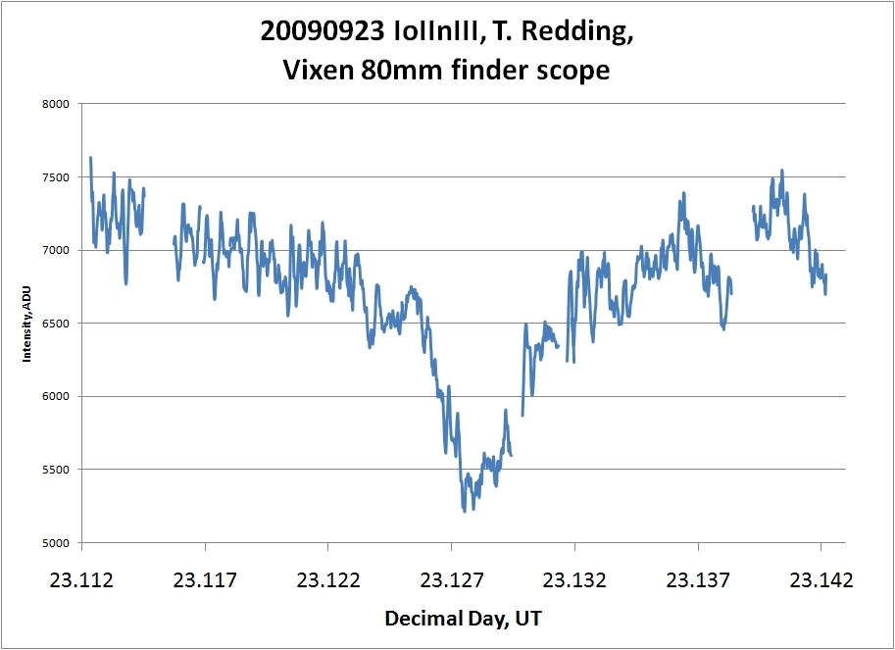
Figure 15. Demonstrates an 80mm finder scope detecting the atmosphere of Io.

- Acknowledgment
Without a doubt this study would not have happened without the contributions of the 11 JME observers. It is no small task collecting an hour of video data, thus generating over 200,000 data points and then photometrically correcting them. Sincere thanks from this author go to the observers: Salvador Aguirre, Dave Clark, Tony George, Michael Hoskinson, Terrence Redding, Andy Scheck, John Talbot, Brad Timerson, and Roger Venable. Also, many thanks are extended to Don Parker, A.L.P.O., for providing such high quality imaging of the planet Jupiter. Thanks to the many peer reviewers who provided numerous comments and suggestions that helped in the analysis of this project. And a final acknowledgment is a must to two fine professionals that provide unending support to amateur research, Brian Warner and Russ Genet.

- References
Arlot, J.-E., Thuillot, W.,Ruatti, C. and 116 coauthors observers of events:
2009, The PHEMU03 catalogue of observations of the mutual phenomena of the Galilean
satellites of Jupiter, Astronomy and Astrophysics, Volume 493, Issue 3, pp.1171-1182

Michael E. Brown* & Richard E. Hill
Discovery of an extended sodium atmosphere around Europa
Nature 380, 229 - 231 (21 March 1996); doi:10.1038/380229a0
http://www.nature.com/nature/journal/v380/n6571/abs/380229a0.html

Burger, M.H. et al. “Mutual Event Observations of Io's Sodium Corona” (2001) http://www.iop.org/EJ/article/0004-637X/563/2/1063/52792.text.html

Europa’s neutral cloud: morphology and comparisons to Io
Matthew H. Burger & Robert E. Johnson
Icarus 171 (2004) 557–560
http://people.virginia.edu/~rej/papers04/Burger_Johnson04.pdf

Degenhardt, S.M., “Io atmospheric extinction predictions for 2009 Jovian Mutual Events” (2009)
http://scottysmightymini.com/mutuals/Io_atm_extinct_predict2009_2010.htm

Degenhardt, S.M., “Jovian Extinction Event (JEE) predictions for 2010” (2010)
http://scottysmightymini.com/JEE/JEE.htm

Gray, B., 2009, Guide 8, planetarium software,
http://www.projectpluto.com/

Miyashita, K., LiMovie, (2008) software to photometrically reduce AVIs.
http://www005.upp.so-net.ne.jp/k_miyash/occ02/limovie_en.html
LiMovie 20030503
http://www005.upp.so-net.ne.jp/k_miyash/occ02/io_ganymede.html

NSDC (Natural Satellites Data Center) database web address:
http://www.imcce.fr/hosted_sites/saimirror/obsindhe.htm

Schneider, N. M. et al., “The structure of Io's corona” (1991), ApJ, 368, 298

Timerson, B., “How To Capture Mutual Events - QuickStart Guide” (2009), (IOTA’s standard observation and reduction method for mutual events),
http://www.timerson.net/IOTA/MutualEvents/Processing a Mutual Event.doc

Voyager 19790213
http://photojournal.jpl.nasa.gov/catalog/PIA00144

Wikipedia Airy disk image
http://en.wikipedia.org/wiki/File:Airy-pattern.svg

